Git – Commands Assignment

TASK 1: Local Repository Setup

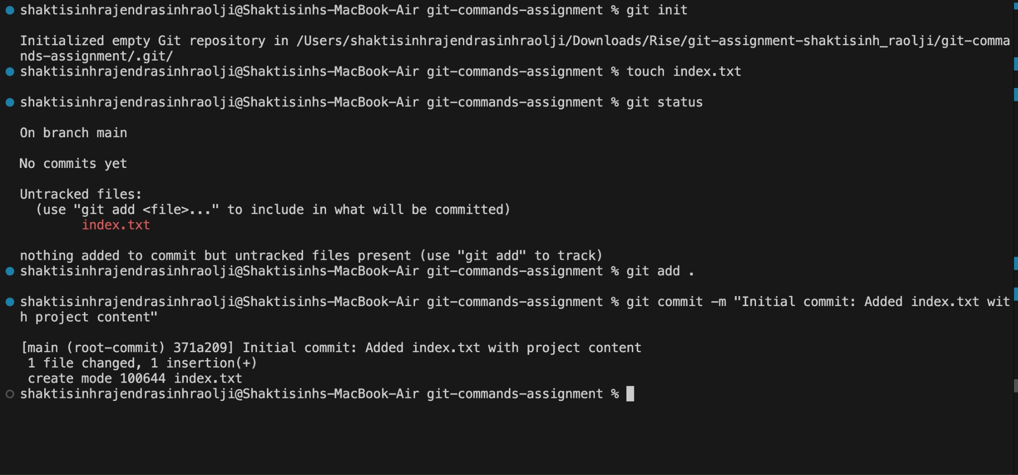

TASK 2: Remote Repository Creation

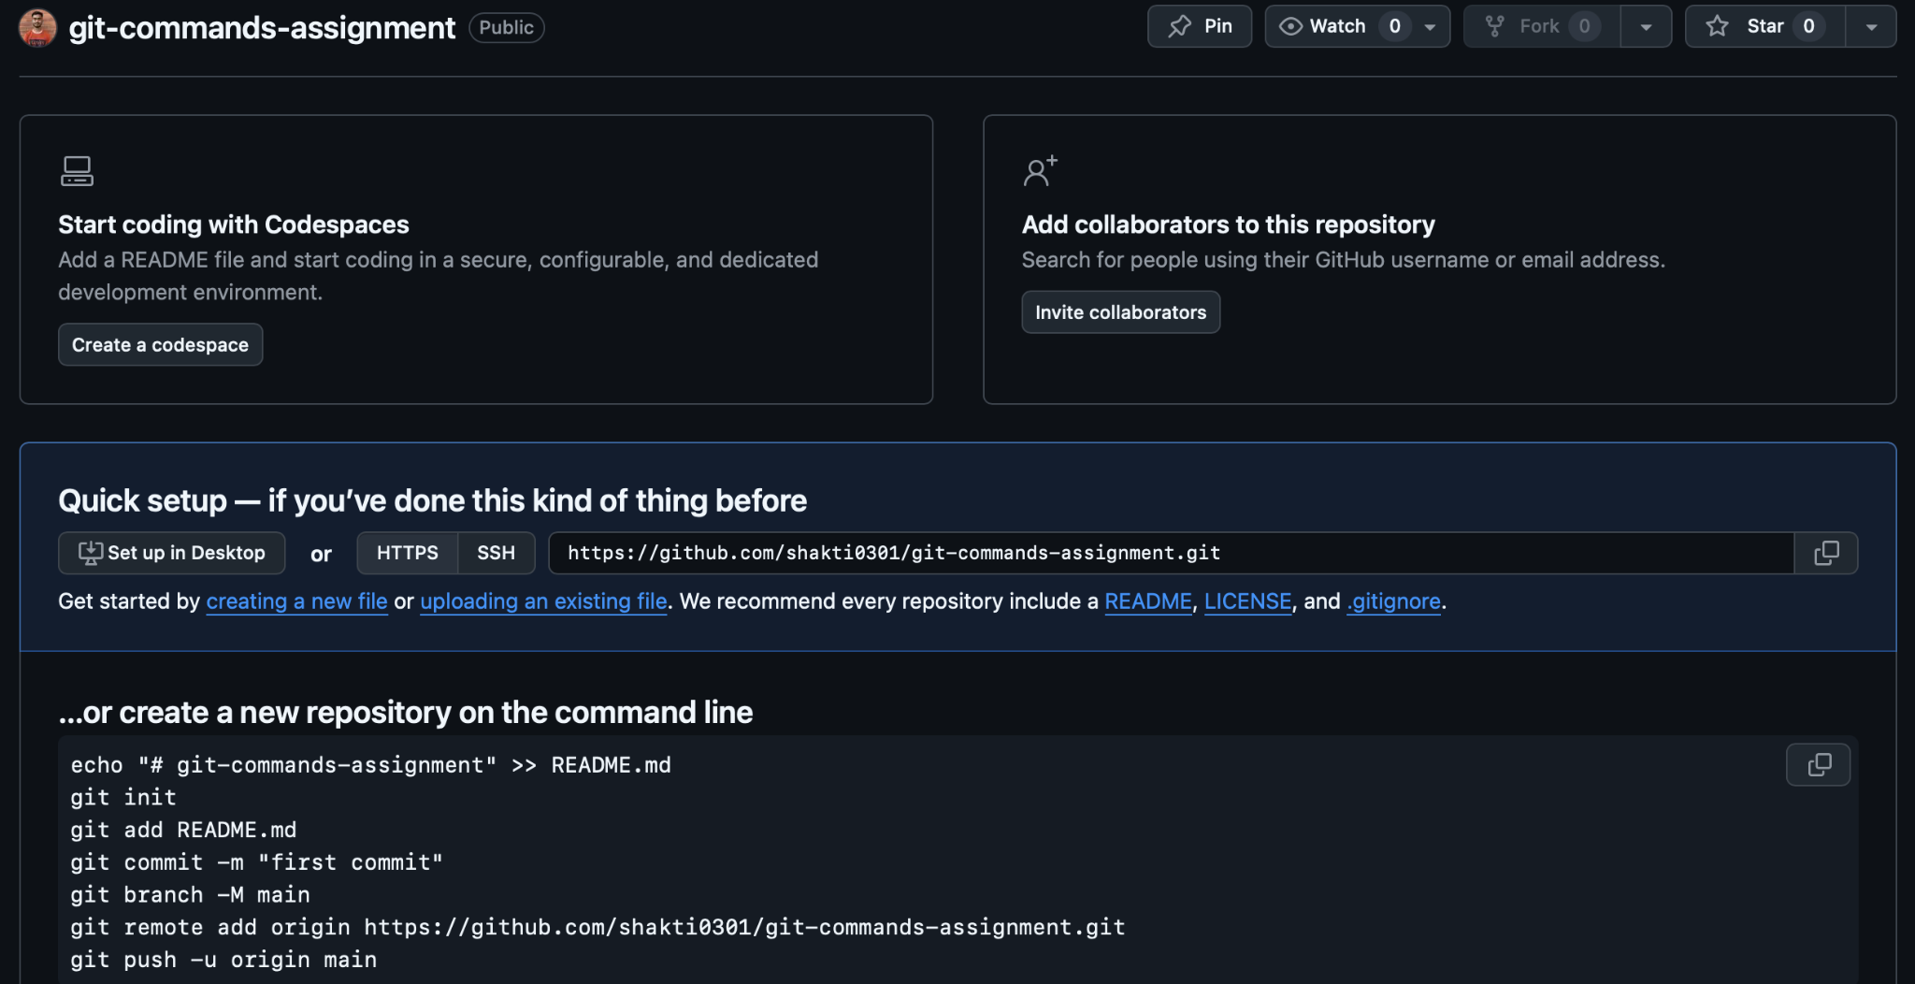

TASK 3: Connect Local Repository to Remote

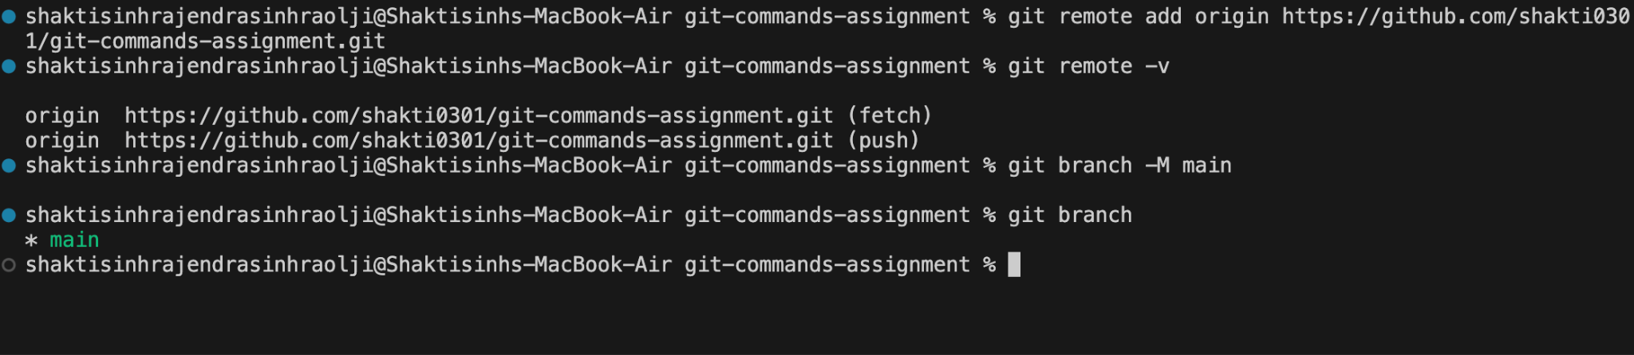

TASK 4: Push Local Changes to Remote

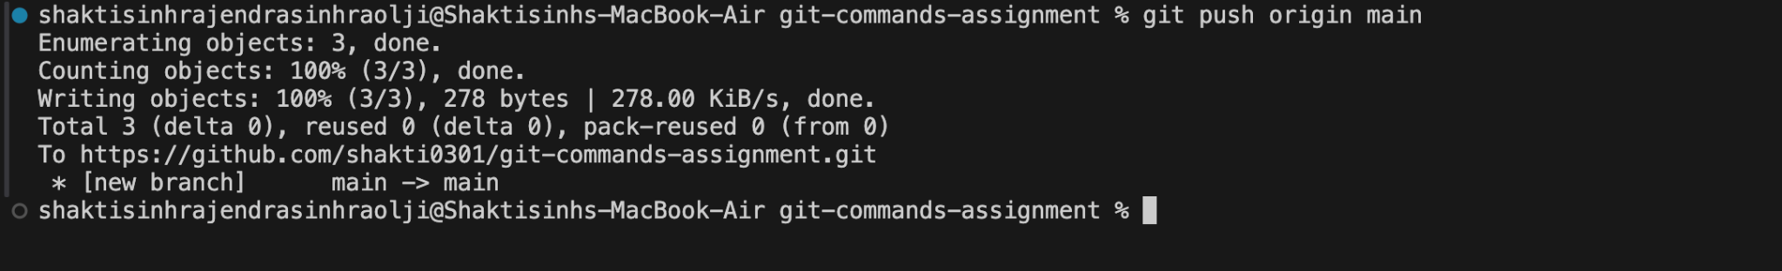

TASK 5: Branch Creation and Work

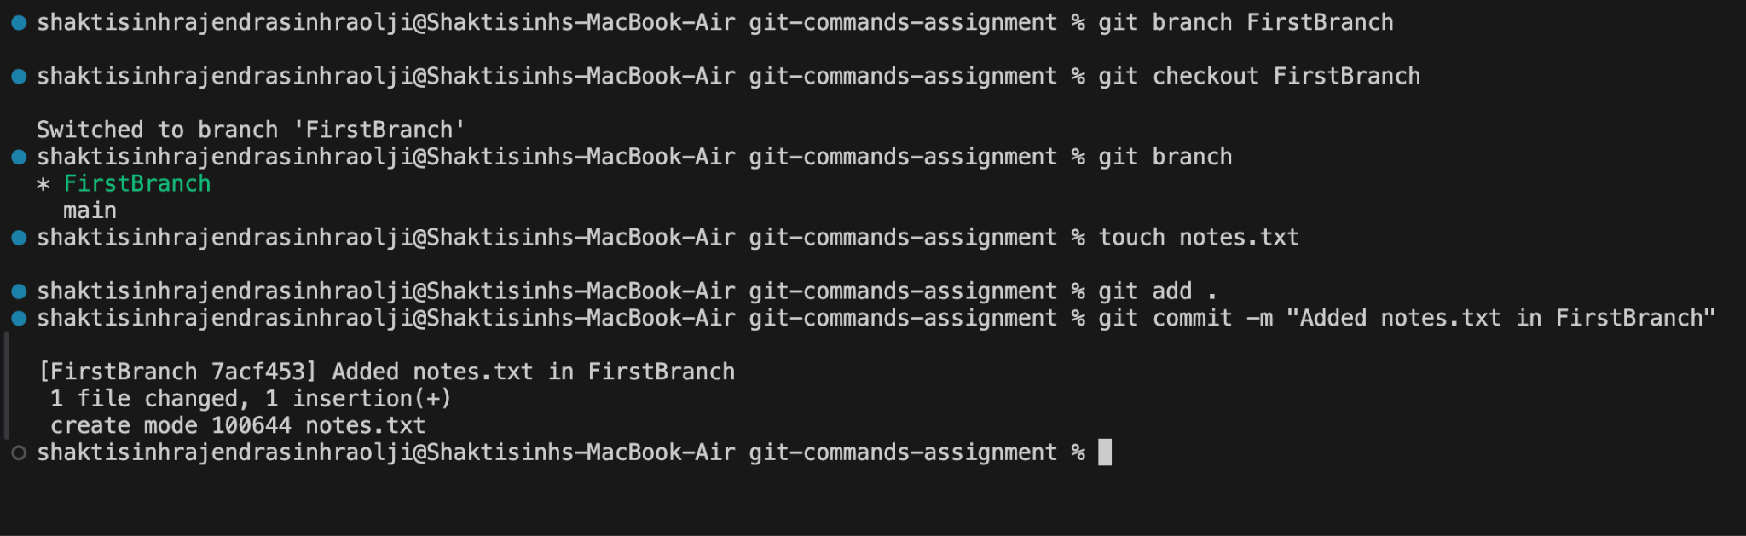

TASK 6: Merge Branch into Main

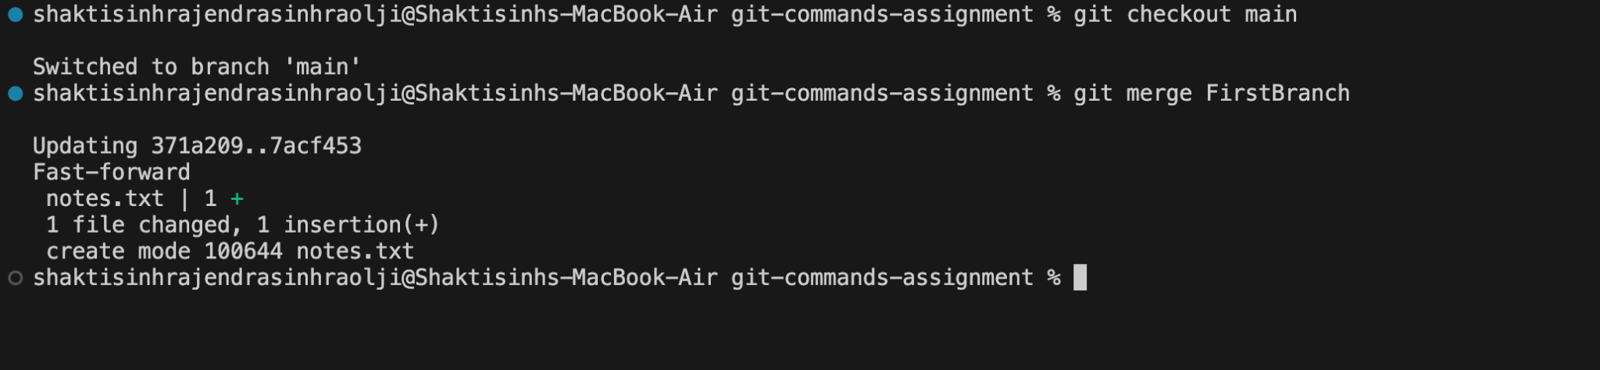

TASK 7 – Final Sync with Remote

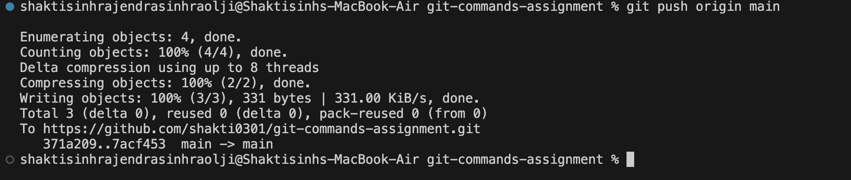

TASK 8 – Simple Pull

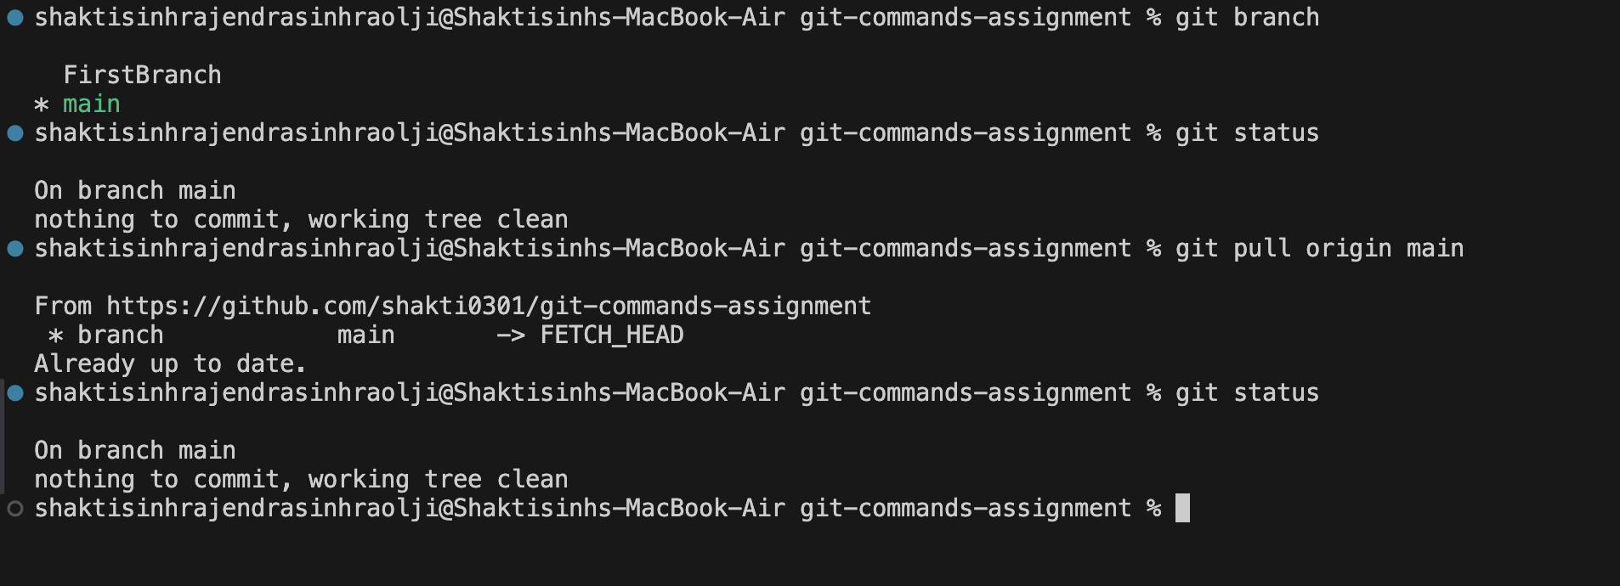

TASK 9 – Push and Pull with Conflict Resolution

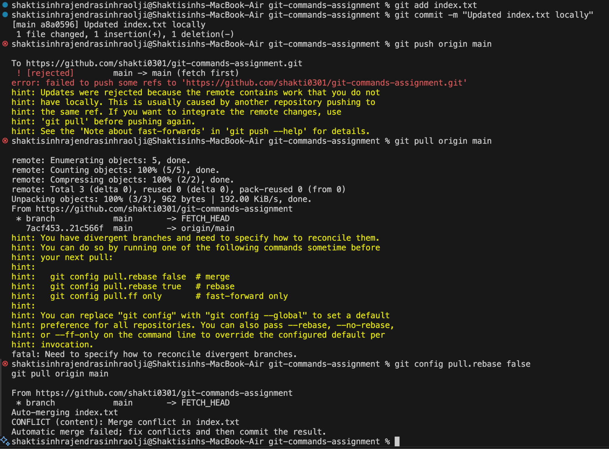

TASK 10 - Clone an Existing Repository

